U-Pb Geochronology Practical: Background

Basic Concepts:
accuracy: measure of the difference between an experimental measurement and the “true” value
precision: measure of the reproducibility of the experimental result
random error: unpredictable fluctuations in observations that yield results that differ from experiment to experiment
systematic error: errors that cause the measurement to differ from the “true” values with reproducible discrepancy

Sample versus Population
A sample is a group of data which is a subset of an infinite population.
population distribution: the “true” distribution of values of a given quantity
sample distribution: the measured distribution of those values; in the limit of infinite measurements, the sample distribution approaches the parent distribution
How do we describe the sample versus population distributions? Often with concepts like the mean, the variance, and the standard deviation.

Parametric statistics
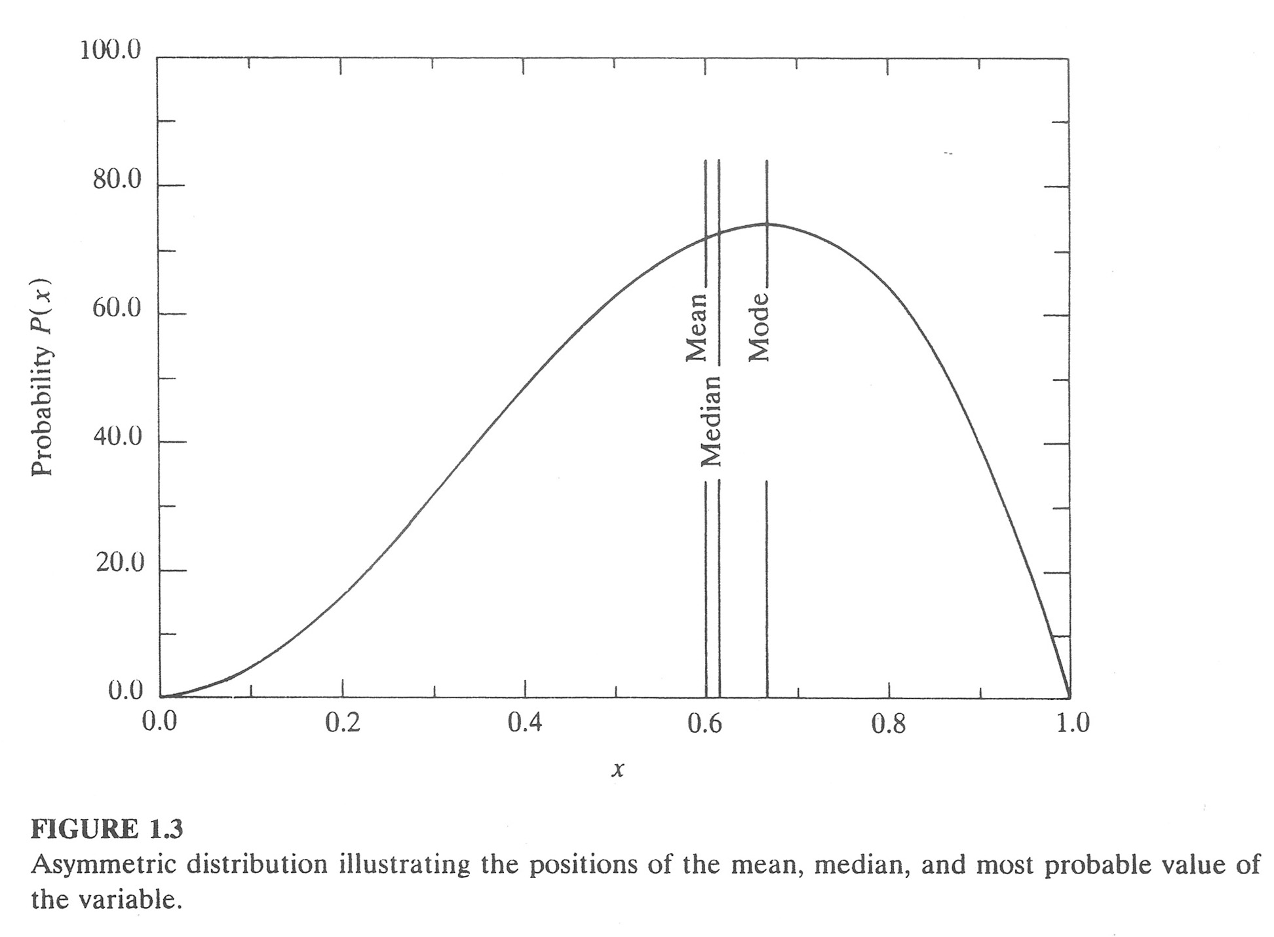
The mode is the most probable value of x

The median (x_{1/2}) is the value for which half the observations are greater and half less

The mean (x) is the average value of a quantity x

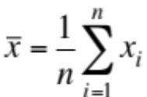 (sample) 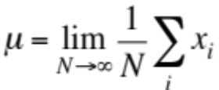(population)

The deviation (d_{i}) of a measurement x_{i} from the mean µ of the parent distribution is the difference between x_{i} and µ

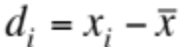 (sample) 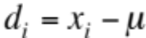 (population)

The average deviation, α, is the (in the limit of infinite measurements) the average of the absolute values of the deviations from the mean µ … but the absolute value is computationally inconvenient…

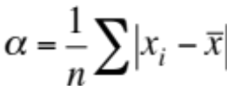 (sample) 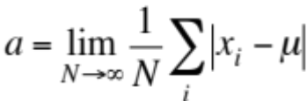 (population)

The variance, σ², is (in the limit of infinite measurements) the average of the squares of the deviations from the mean µ

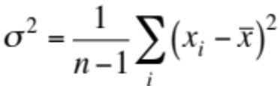(sample) 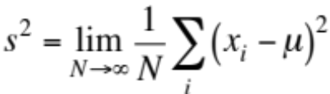(population)

The standard deviation, σ, is (in the limit of infinite measurements) the square root of the variance; the standard deviation estimates the likelihood of a measurement falling within a certain interval about the mean:

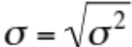(sample) 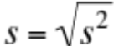 (population)

The standard error of the mean is a measure of how well the sample mean, x, estimates the population mean, µ … it does not represent the same thing as the standard deviation! It is calculated from the standard deviation divided by the square root of the number of measurements:
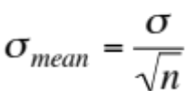

Note that as n approaches infinity, the standard error approaches zero, e.g. the sample mean must approach the population mean.

Distributions
Recall that a histogram is a graph of the frequency of binned measurements; the apparent shapes of distributions illustrated in histograms are highly sensitive to the choice of bin size…
A probability density function appears as the smooth curve over the columns of a histogram, in the limit of infinite measurements. The shape of the probability density function is independent of the choice of bin size, and thus always “looks” the same unlike associated histograms.
The most commonly observed (or assumed) distribution in science and engineering is the Gaussian or normal distribution, which is the symmetric bell-shaped curve arising when the number of different possible outcomes is infinite but the probability of each is finite:
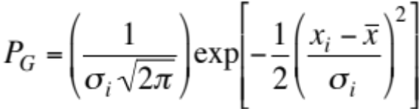 (sample)
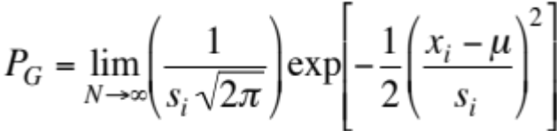 (population)
This equation yields the so-called “unit” Gaussian curve; the integral under the curve is of unit area (=1). It can be subsequently scaled to n measurements.
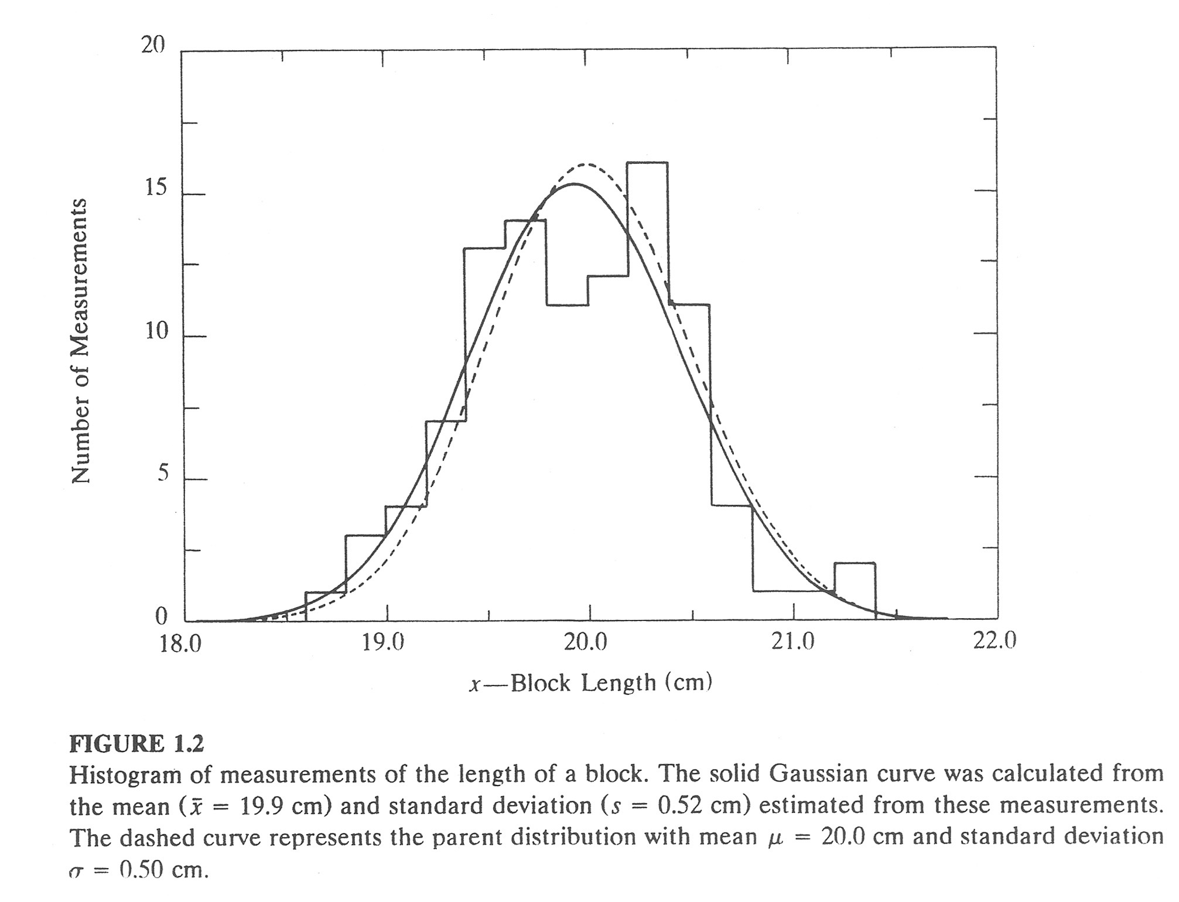
Confidence Intervals
The probability that a measurement will differ from x by some amount Δx is called the confidence interval; it is simply the area under the unit probability density function, bound by ±Δx:

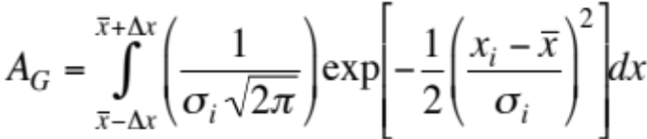

For a Gaussian probability function,
If Δx = σ, then A_{G} = 0.68269 ~ 68% … the “1σ confidence interval”
If Δx = 2σ, then A_{G} = 0.95449 ~ 95% … the “2σ confidence interval”

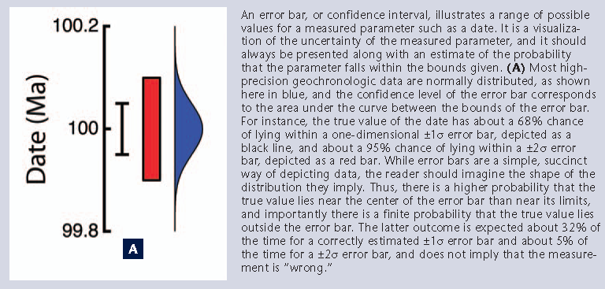
Schoene et al. (2013)

Note that in high-precision geochronology the tradition is to tabulate and illustrate analytical data with their 2σ (95%) confidence interval uncertainties.
By contrast, in situ geochronological methods (ion probe, LA-ICPMS) traditionally illustrate their data with 1σ (68%) confidence interval uncertainties, e.g.
“Even a geologist should be able to multiply by two…”
unnamed physicist and ion microprobe developer
Constructing Probability Functions (and Histograms)

Two approaches:
1) Assume that the total sample distribution can be modeled as a specific probability density function. Then, the area under a normalized probability density function is made equal to the area of the equivalent histogram. For example:
- Calculate the unit Gaussian probability function from the appropriate eqn.
- Normalize the probability function (Pg) by:

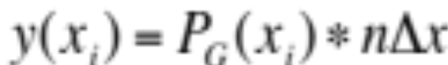

2) Assume that each measurement has a normally distributed uncertainty with a known variance. Then you can assign a unit Gaussian curve to each measurement, and then sum all these up along the x-axis. Again the area under the probability density function is equal to the area under the histogram. The benefit of this approach is that it can handle non-uniform variances for each observation.

Weighted Mean and Variance
Following from the idea that the individual observations within a sample may have non-uniform variance, it is common to weight each observation by the inverse of its variance when calculating the mean of the sample distribution:

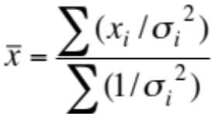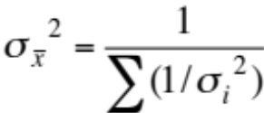

The standard error of the weighted mean decreases with the number of measurements.

Statistical evaluation of the best-fit solution
How do we evaluate how well a best-fit solution, in this case the weighted mean of a normal distribution, describes our data distribution?
We can define our goodness-of-fit parameter, χ², as the sum of the squares of the deviations of our observations from our model mean value, weighted by the variances of those observations:
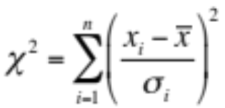
In geochronology, we have a tradition of normalizing the χ² statistic by the degrees of freedom of the system to derive the Mean Squared Weighted Deviation or MSWD (e.g. Wendt and Carl, 1991). This statistic quantifies the extent to which data scatter from the best-fit solution beyond stated uncertainties.

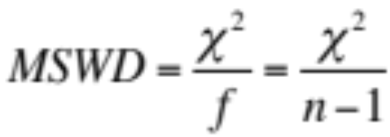

ƒ is the degrees of freedom of the model, e.g. the number of experimental parameters (measurements) – number of model parameters (unknowns)

The expectation (mean) value of the MSWD is 1, in other words:
- MSWD = 1… scatter of data about the model is accurately described by analytical uncertainty
- MSWD >> 1… scatter of data about the model is beyond analytical uncertainties; the model is a poor fit to the data or the experimental error is underestimated
- MSWD << 1… scatter of data about the model is much less than the analytical uncertainty; experimental error is probably overestimated

Wendt and Carl (1991) established the frequency distribution of the MSWD about the mean value of 1, as a simplified function of ƒ:



